Clean Code Notes
- All file names - only in lowercase;
- Always use const keyword instead #define;
- Not use C – style type conversion like:
s = double (x % 100);
- Use a single style formatting code:
- the same number of spaces:
- before and after arithmetical and logical operators like <, >, =, & etc.
like: s = double (x % 100); space after “s”, after “=”, after “x” etc.
- the same number of indent:
- on the left hand of border work space;
- in {} blocks and constructions;
- Follow the numbers of brackets ;
- Names functions, classes, variables, constants etc. with meaning;
- Names of classes:
- Names of abstract classes complement prefix – I (class ISocket);
- Names of implementation classes complement prefix – Imp (class SocketImp);
- Names of classes is a part hierarchy complement prefix – C (class CFigure);
- Names of exceptions class complement prefix – exception (class BadArgException);
- Names of functions:
- if function return boolean value name function complement is_ (is_digit);
- if function find value in container name complement has_ (has_primeNumber);
- if method return or set value any field , name function complement get_, set_ (set_volume, gel_volume);

Optimization
Aligning memory:
Change sequence location of data types in structures:

Not true:
struct MyStruct1{
char m_c;
void *m_p;
int m_i;
};

Posses objects type in descending order of their volume.

True:
struct MyStruct2{
void *m_p;
int m_i;
char m_c;
};

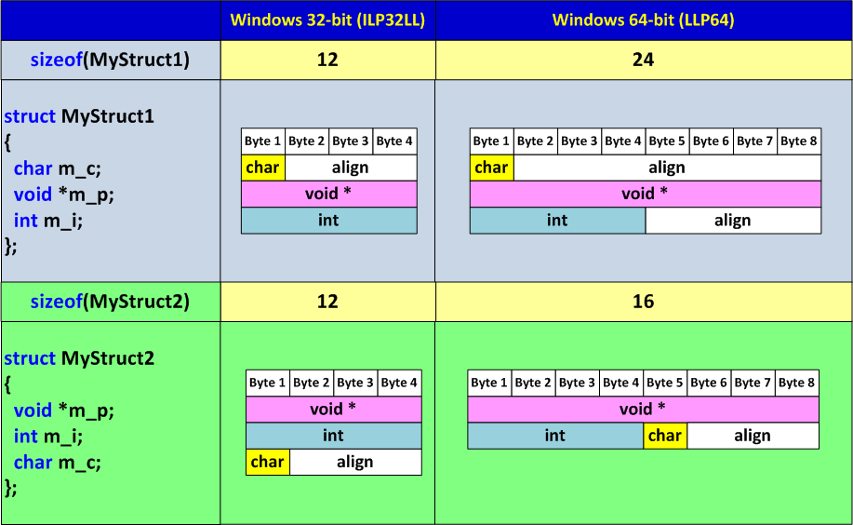
It work for variables to;

If you use big data containers in 64bit system, for counters use data type is size_t:
std::vector<int> vect;
for (size_t i = 0; i <vect.size() i++){
/* something */
}

When working with single precision (float) values:
• Use the f or F suffix (for example, 3.14f) to specify a constant value of type float.
• Use function prototypes for all functions that accept arguments of type float.

Const

const int M_PI = 3.14; // value is constants
const int *p = 3.14; // value is not change, pointer is changeable
int *const p = 3.14; // value is changeable, pointer not change
const *int const p = 3.14; // value is not change, pointer is not change

